|  |
| --- |
| Faurecia Robot Electric Vacuum actuator Module Manual |

|  |
| --- |
| SUMMARY |

|  |
| --- |
| This document is a guide for customers to analyze common problems on site and provide solutions to the problems. |

|  |
| --- |
|  |

|  |
| --- |
| Disclaimers |

|  |
| --- |
| We have tested the content described in this document. However, errors are inevitable and cannot be guaranteed to be absolutely correct and fully meet your usage needs. The content of this document may be updated at any time, and we welcome your suggestions for improvement. The document content may be updated at any time  If there are any changes, no prior notice will be given |

Catalogue

1 Overview of installation of FR robot electric vacuum actuator module 3

2 Installation of electric vacuum actuator module 4

2.1 Assembly of installation plate for electric vacuum actuator 4

2.2 Installation of S485 control box mounting plate 5

2.3 Installation of electric vacuum actuator 5

2.4 Installation of Ethernet to 485 components 6

2.5 Assembly of electric vacuum actuator wiring 6

2.6 Assembly of electric vacuum actuator wiring 8

3 Suction cup communication configuration 9

3.1 Network cable connection 9

3.2 Electric vacuum suction cup 485 configuration 10

3.3 Robot Teaching Interface Function Configuration 11

3.4 Unicast Mode Function Configuration 12

3.5 Broadcast Mode Function Configuration 13

4 Electric vacuum suction cup test 15

4.1 Programming 15

# Overview of installation of FR robot electric vacuum actuator module

Installing array suction cups at the end of the robot can help the robot quickly deploy material grabbing workstations in different scenarios. The number and layout of suction cups can be customized for materials of different sizes and shapes, improving work efficiency and stability. Collaborative robots support suction cup arrays consisting of up to 20 suction cups, which can individually control the grasping and releasing of a certain suction cup, or control the synchronous action of all suction cups in the entire connected array. This manual describes the installation and debugging methods of the electric vacuum actuator module for FR robots

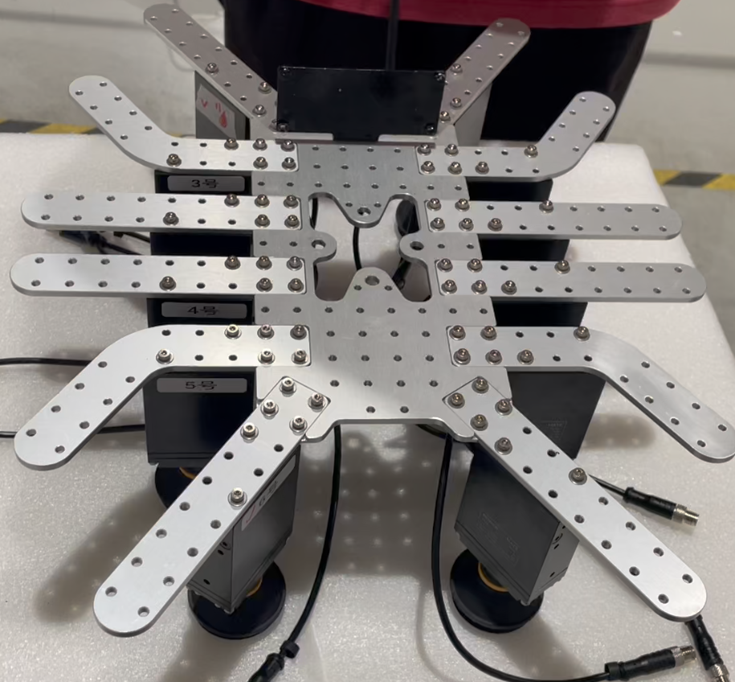

1-1 Schematic diagram of electric vacuum actuator module

# Installation of electric vacuum actuator module

## Assembly of installation plate for electric vacuum actuator

As shown in Figure 2-1 and Figure 2-2, use M3 * 6 full tooth hexagonal socket head screws with M6 flat washers to install the edge plate on the mounting plate

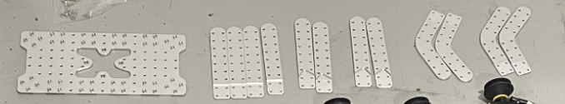2-1 Install the edge plate component of the installation board

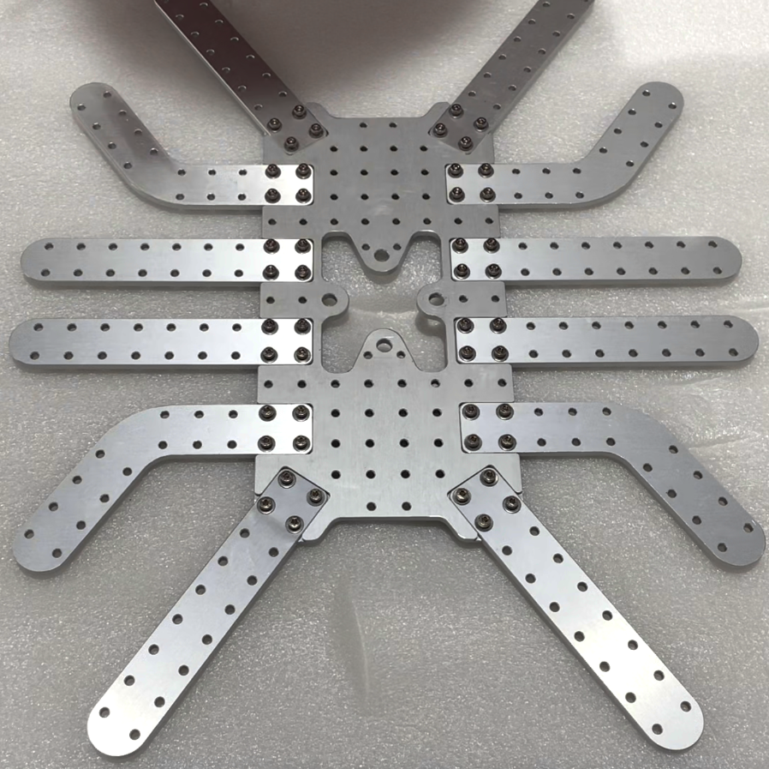

2-2 Installed installation board completed

## Installation of S485 control box mounting plate

Install the S485 control box mounting board, as shown in Figure 2-3.

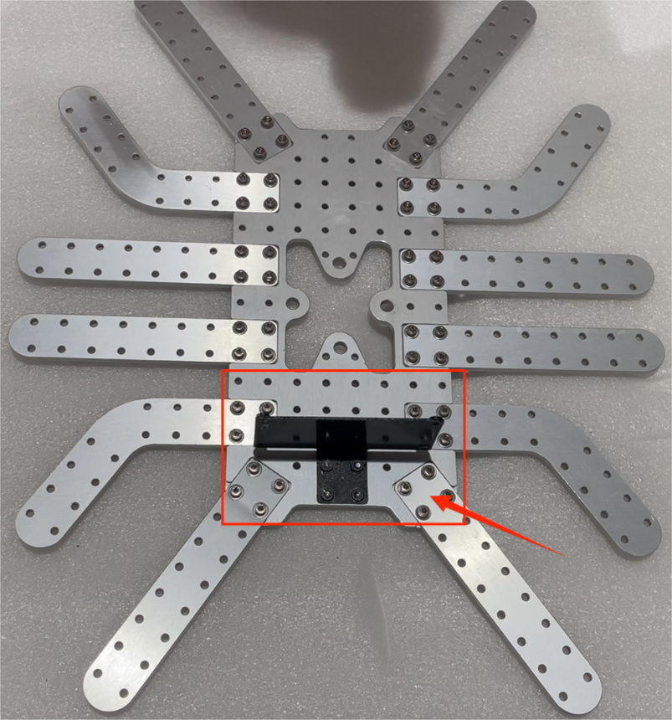

2-3 485 component installation board

## Installation of electric vacuum actuator

Install the prepared electric vacuum actuators on the mounting plate in sequence (note that there are serial numbers on the electric vacuum actuators, it is recommended to install them in sequence according to the serial numbers), as shown in Figure 2-4.

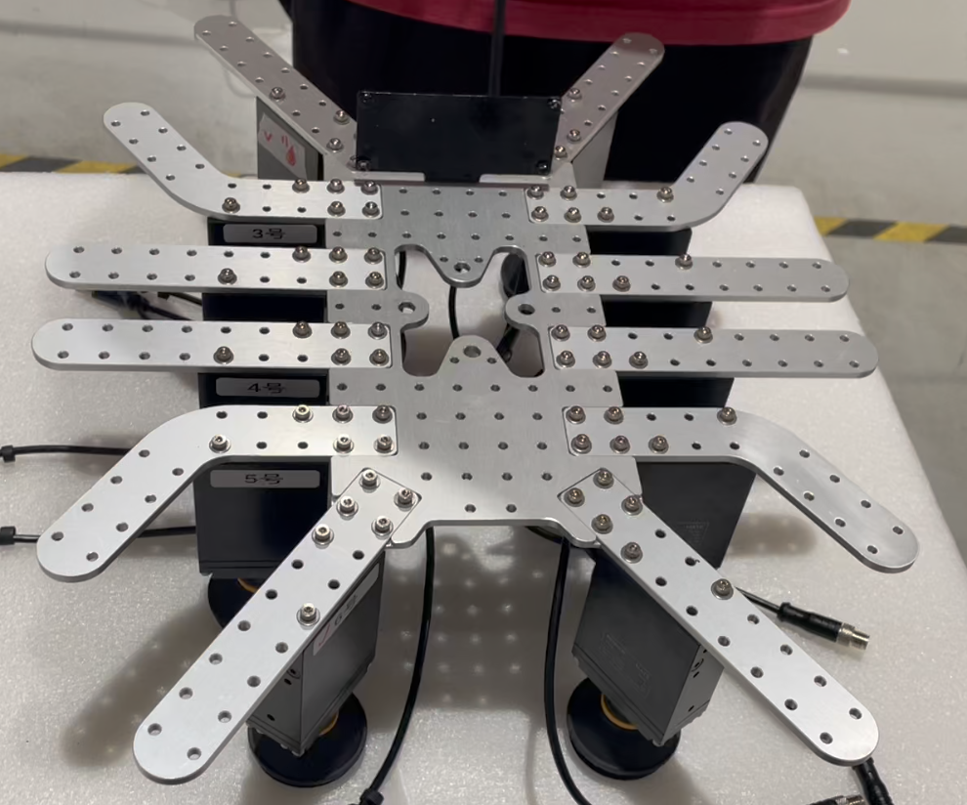

2-4 Installation of electric vacuum actuator completed

## Installation of Ethernet to 485 components

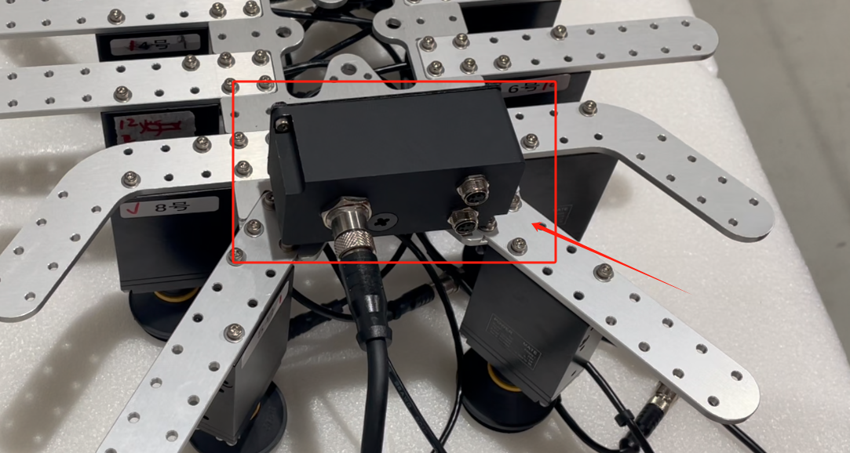Use M3 * 6 hexagonal socket head screws to install the Ethernet to 485 component onto the S485 control box mounting plate, as shown in Figure 2-5.

2-5 Installation of Ethernet to 485 components

## Assembly of electric vacuum actuator wiring

Multiple electric vacuum suction cups need to be connected in sequence, with a maximum of 10 suction cups connected to one wire. The demonstration in the figure shows 12 suction cups, each with a serial number. They are connected to one wire according to serial numbers 1-10 and another wire according to numbers 11-12, as shown in Figure 2-6.

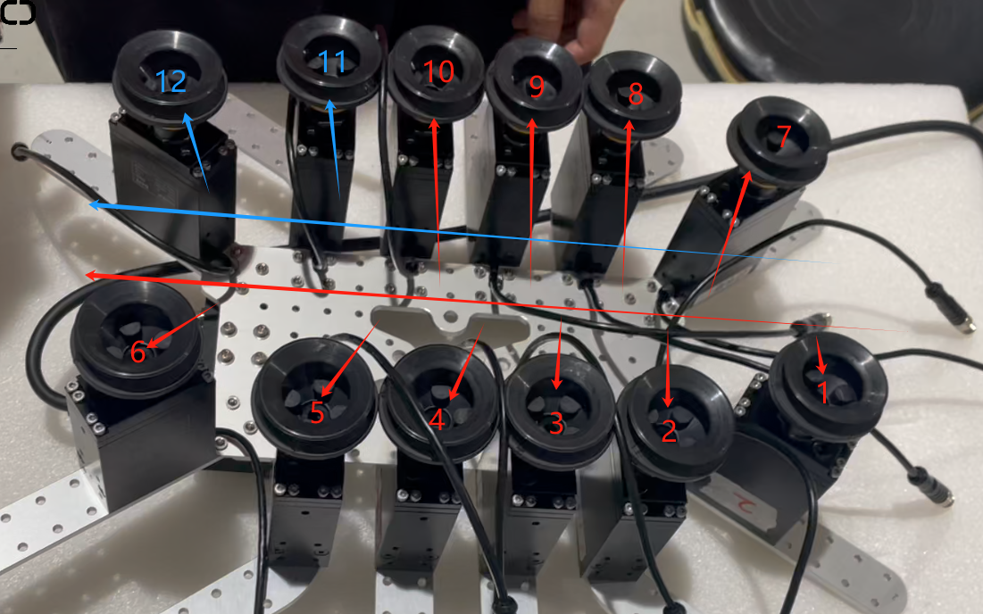2-6 Installation of electric vacuum suction cup

## Assembly of electric vacuum actuator wiring

Use M6 * 10 hexagonal socket head screws to install and fix the electric vacuum actuator module to the end of the robot, as shown in Figure 2-7.

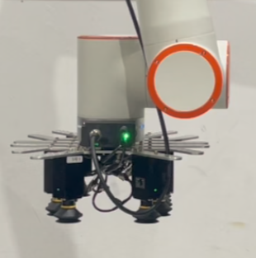2-7 Installation of electric vacuum actuator module

# Suction cup communication configuration



## Network cable connection

Connect the Ethernet to 485 component, robot wabapp, and computer to the POE switch via Ethernet cable, as shown in Figure 3-1.

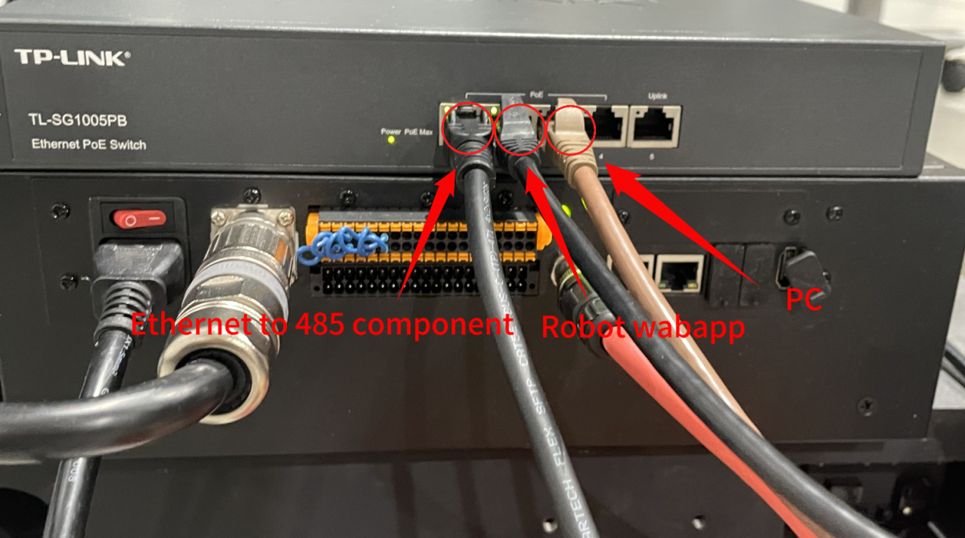-3-1 Network cable connection

## Electric vacuum suction cup 485 configuration

Open the computer, confirm that the computer and suction cup are in the same network segment, click "Search Device", select the suction cup found in the search, and configure the suction cup communication as shown in Figure 3-2.

① Ethernet end configured as TCPServer, IP The address is 192.168.58.10, the port number for port 1 is 50001, and the port number for port 2 is 50002;

② The baud rate configured on the 485 end is 115200, with data bit 8, stop bit 1, and no checksum.

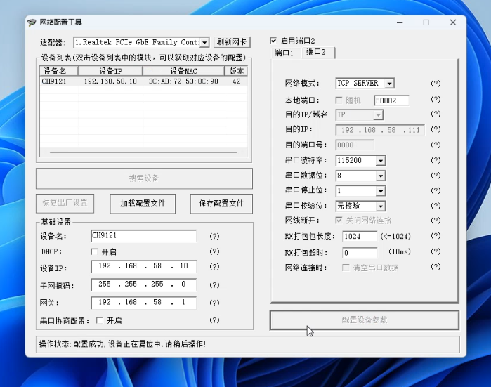

3-2 485 configuration interface

## Robot Teaching Interface Function Configuration

Open WebApp, click on "Initial Settings", then "Peripherals", and finally "Array Suction Cup"; There are two control modes for the array suction cup: unicast mode and broadcast mode. Choose unicast mode.

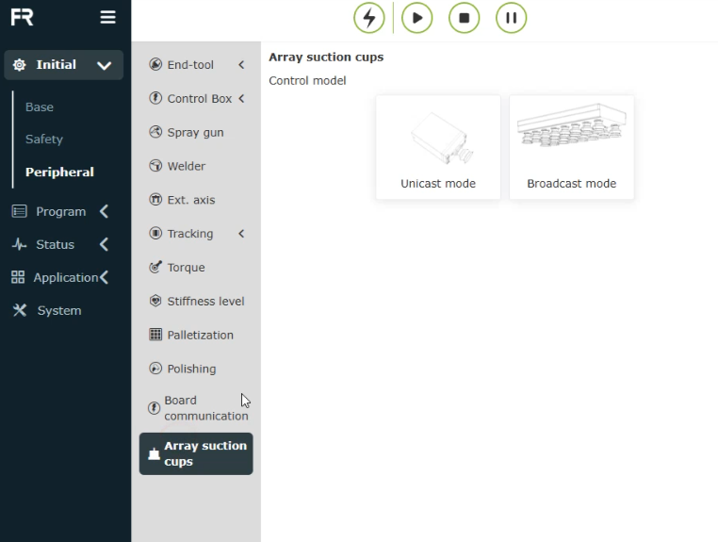

3-3 Unicast Mode

## Unicast Mode Function Configuration

Configure the communication protocol for each suction cup based on its slave ID and vacuum level in the array. Select station number 1, enter the maximum vacuum degree, minimum vacuum degree, and capture timeout (timeout not yet open), and click the "Configure" button. At this point, the suction cup protocol with protocol number 1 appears in the "Device Operation and Status" column, and all currently configured slave numbers will be displayed on the "Manual Configuration" and "Slave Number" labels.

Configure 12 vacuum suction cups in sequence as shown in Figure 3-4.

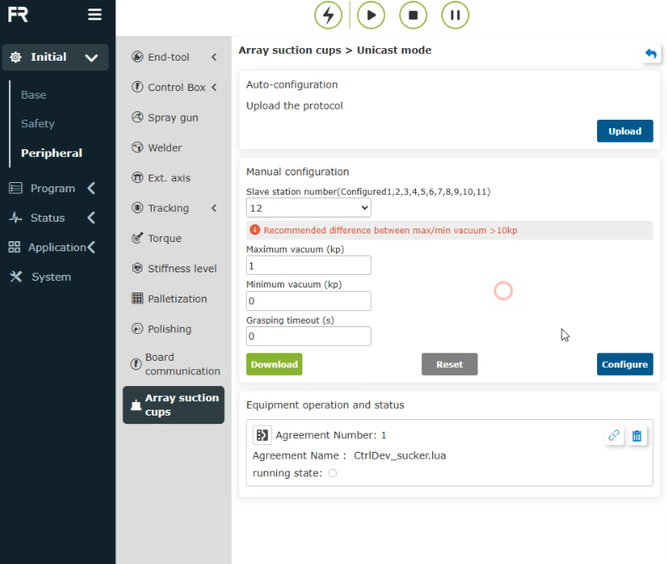

3-4 Unicast Mode

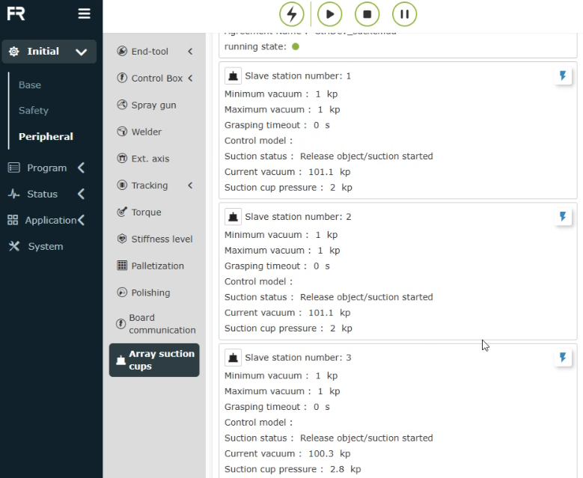

3-5 Unicast mode communication status

## Broadcast Mode Function Configuration

Open WebApp, click on "Initial Settings", then "Peripherals", and finally "Array Suction Cup". First, configure all the required suction cup slaves in unicast mode (only configure, without establishing communication protocol connections). Click on "Broadcast Mode", enter the "Maximum Vacuum Degree", "Minimum Vacuum Degree", and "Capture Timeout Time" of the suction cup in "Parameter Configuration" (timeout time is not yet open), click the "Configuration" button, and the broadcast mode communication protocol will appear in the "Device Operation and Status" box. In broadcast mode, setting the vacuum degree parameter takes effect for each connected suction cup, as shown in Figure 3-6.

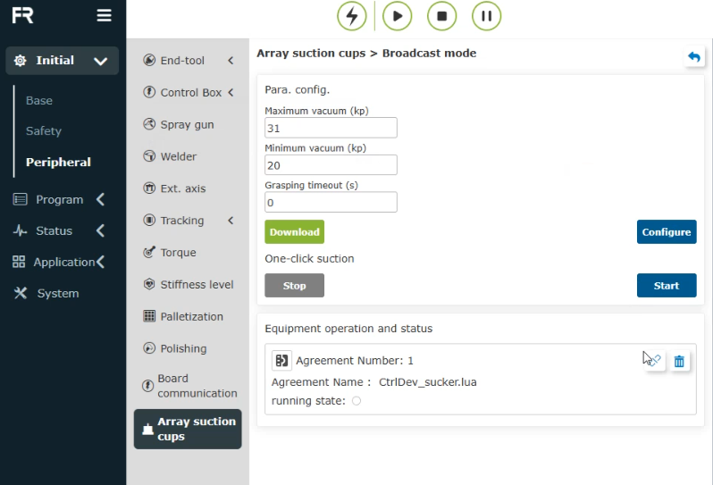

3-6 Broadcast Mode

Click the "Connect" button in the "Protocol Number 1" operation box, and the "Running Status" indicator light will turn on, indicating that the robot has established a communication connection with the array suction cup. After successful connection, the list of all connected suction cup operation boxes will be displayed in the "Device Operation and Status" column. Click "Start" in "Parameter Configuration" and "One Click Suction", and each suction cup in the array suction cup will perform the "set vacuum suction" action. Click "Stop", and each suction cup in the array suction cup will stop the suction action, as shown in Figure 3-7.

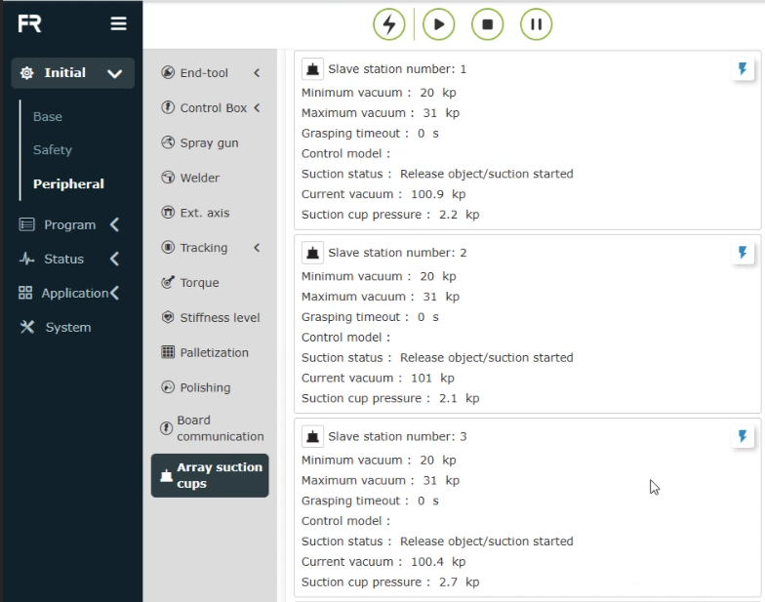

3-7 Broadcast mode communication status

# Electric vacuum suction cup test



## Programming

The suction state set by the broadcast mode control command is effective for all suction cups currently connected. Click on the 'Suction Cup Control Command', select the control mode as' Broadcast Mode ', input suction status as 1 (suction according to maximum vacuum degree)/input suction status as 3 (stop suction). Click the "Add" button to generate the program.

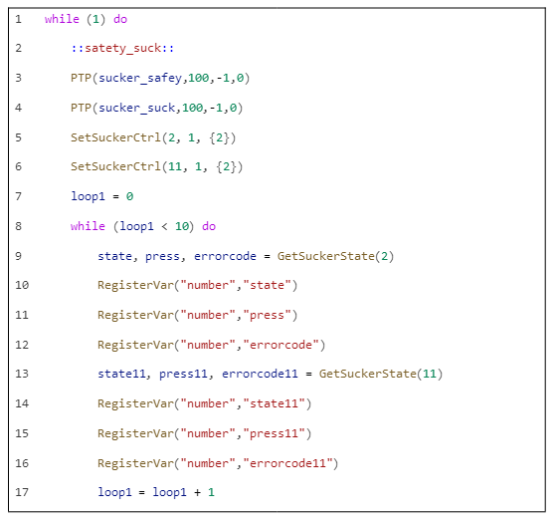

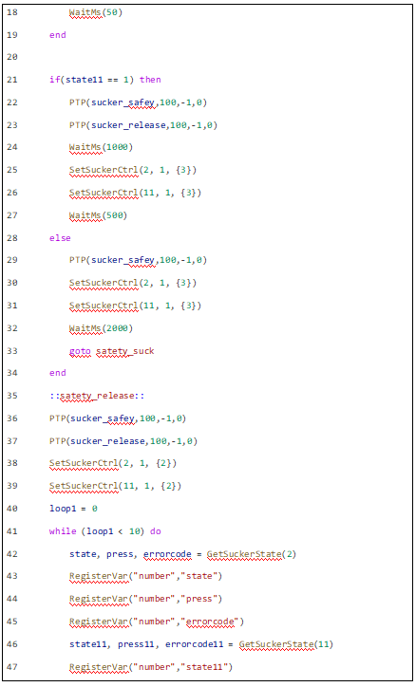

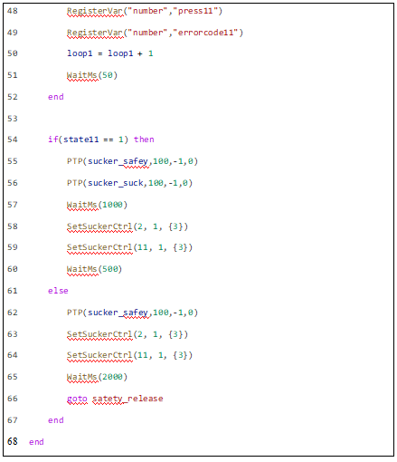

4-1 Example Lua program